**DYNAMIC ROUTE OPTIMIZATION WITH TRAVELLER PRIORITIZATION**

**(SOFTWARE DESIGN SPECIFICATION)**

**Dynamic Route Optimization with Traveller Prioritization**

The decomposition of the project is as the following three modules,

* User Ecosystem
* Core Ride Management System
* **Advanced Mobility Services**

**MODULE 1:** USER ECOSYSTEM (AUTHENTICATION + PROFILE MANAGEMENT)

* **Authentication Flow:** Secure onboarding for admins, travellers, and drivers via role-based registration and encrypted login.  
  Session management ensures continuous, authorized access and prevents unauthorized activity.
* **Profile Management:** Users personalize profiles—travellers set preferences, drivers manage availability.  
  Ratings build trust, and complete profiles boost route accuracy and priority decisions.
* **Multi-role Dashboard:** Dashboards adapt to user roles: admins get system tools, others see relevant ride data.  
  Access control ensures each user views only their authorized features and information.

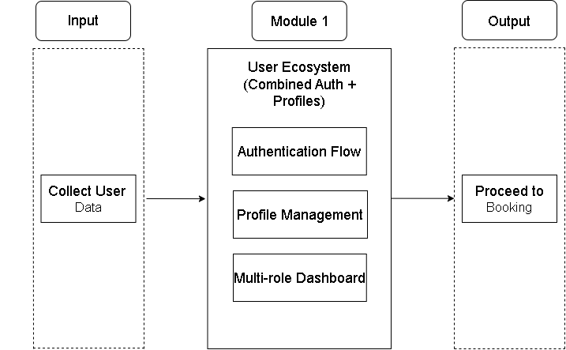

**Fig 2.1:** User Ecosystem

**INPUT AND OUTPUT**

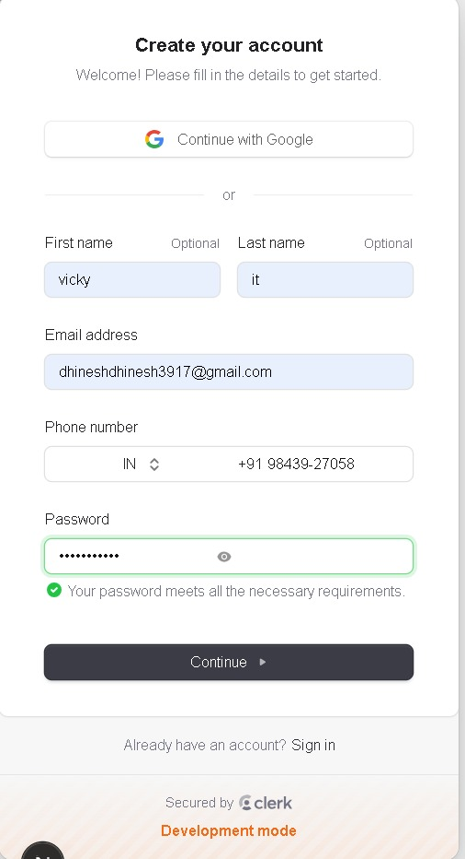

**Fig 2.2:** Collect User Information

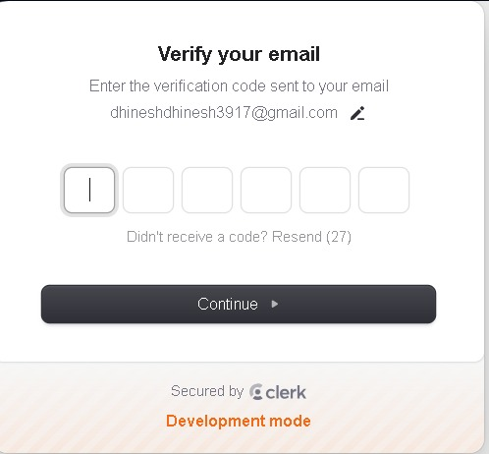

**Fig 2.3:** OTP Verification

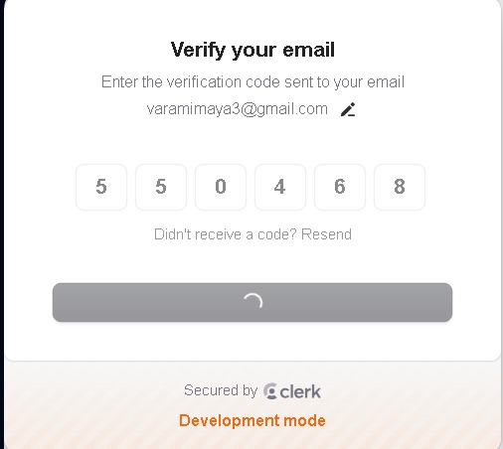

**Fig 2.4:**Verifing User Email Id

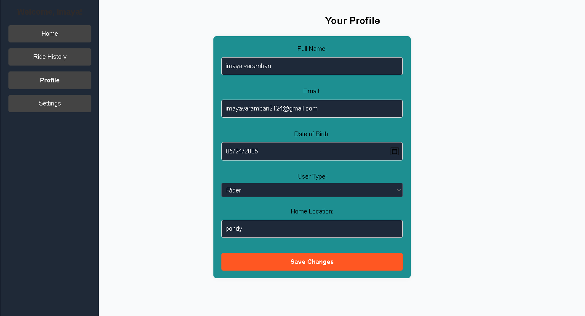

**Fig 2.5:** User Profile

**MODULE 2:** **CORE RIDE MANAGEMENT SYSTEM**

* **Ride Lifecycle Management:** Manages the complete ride journey from initiation to completion. The process starts with the user booking a ride, followed by intelligent driver matching based on proximity and availability. Upon confirmation, the system handles payment securely and tracks the ride through to successful completion.
* **Dynamic Pricing:** Implements a smart pricing engine that adjusts fares in real-time. The system starts with a base fare calculation, then applies surge pricing logic during high-demand periods. Fares are transparently displayed to users before confirmation, ensuring dynamic yet fair pricing.
* **Real-time Tracking:** Enables live tracking and updates throughout the ride. This includes constant driver location updates, accurate ETA (Estimated Time of Arrival) calculations, and route optimization that adapts to traffic conditions and user priority levels. This ensures both efficiency and reliability of the service.

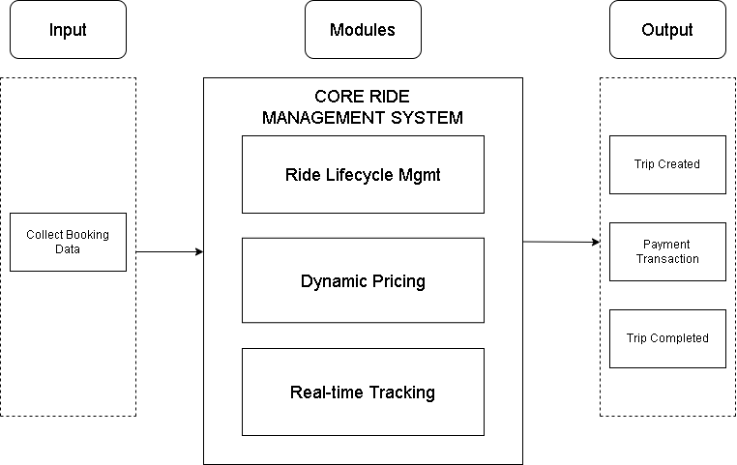

**Fig 2.6:** Core Ride Management System

**INPUT AND OUTPUT**

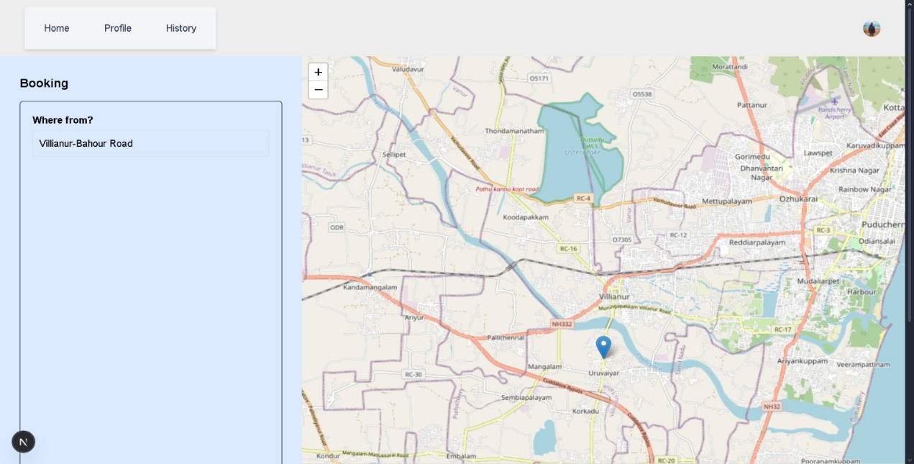

**Fig 2.7:** User Selects Pickup And Destination Locations

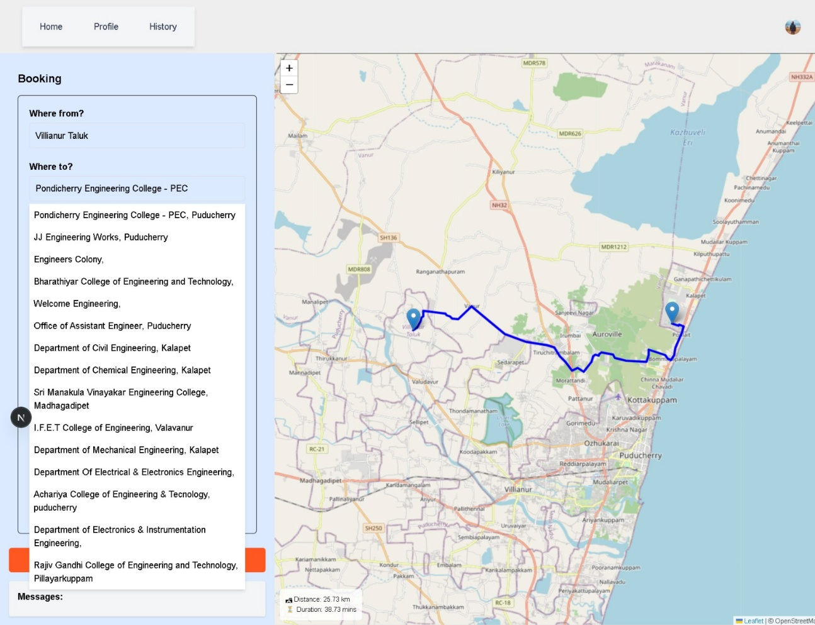

**Fig 2.8:** System displays optimized route, estimated distance, duration, and driver assignment.

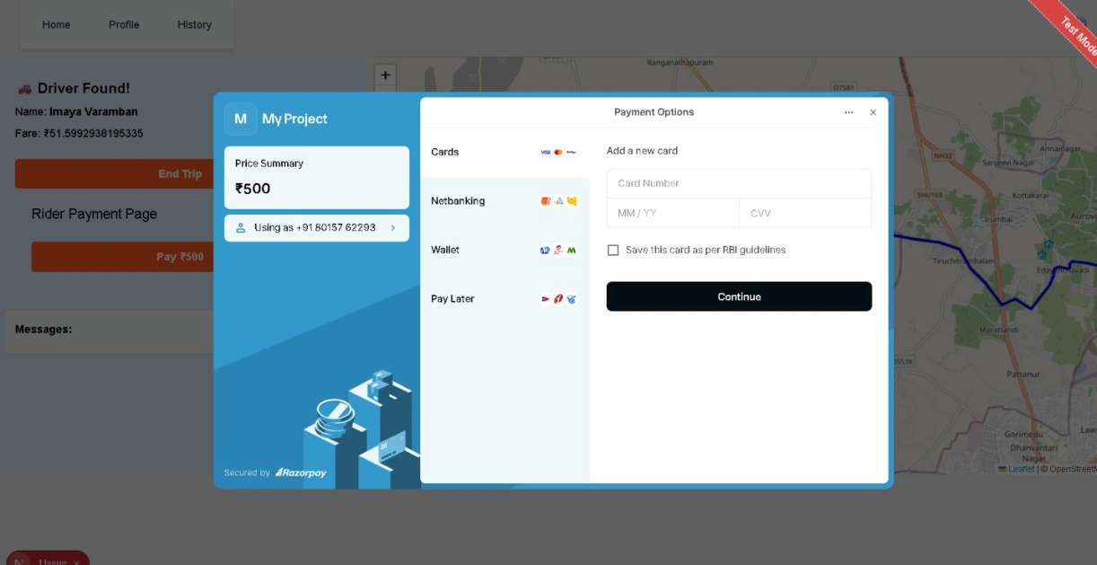

**Fig 2.9:** Payment Gateway Using Razorpay

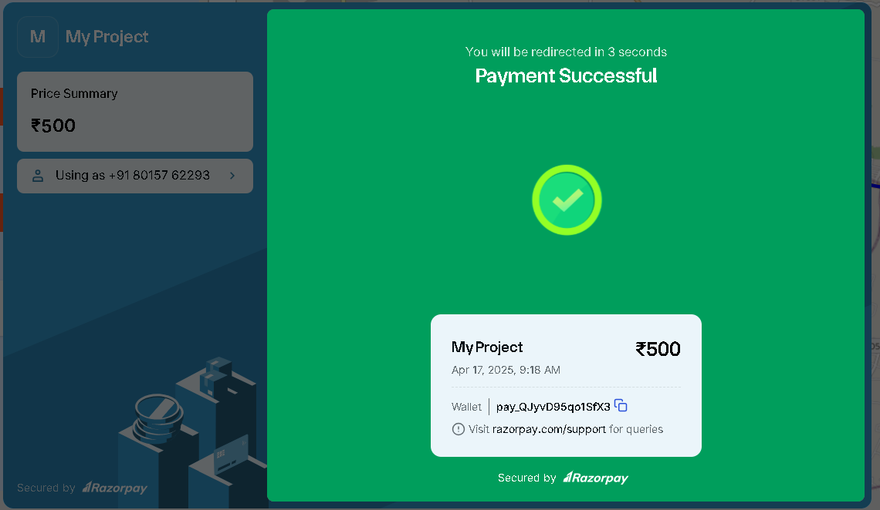

**Fig 2.10:** Traveller Side

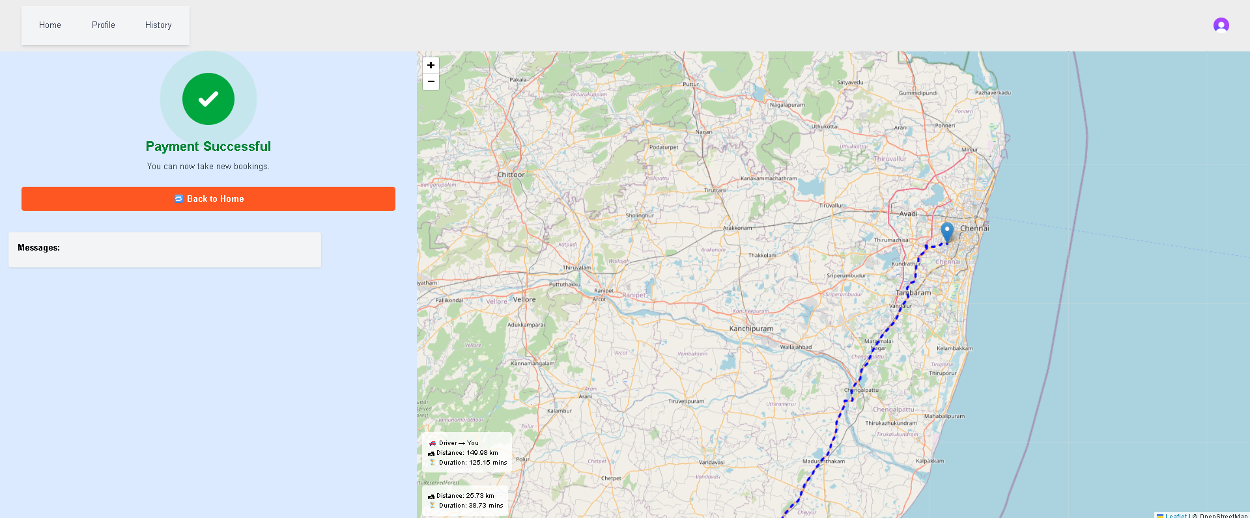

**Fig 2.11:** Driver Side

### **MODULE 3: ADVANCED MOBILITY SERVICES**

* **Route Optimization and Suggestions**: The system performs path optimization to suggest the best routes for drivers and travellers, considering real-time traffic and route data. It also allows travellers to select multi-point routes and view optimized or alternate paths.
* **Traffic Simulation and ETA Updates**: By simulating live traffic movement, the system provides more accurate travel time estimations (ETA), enhancing journey planning and real-time tracking for both stakeholders.
* **Zone-Based Pricing and Visualization**: The module applies dynamic zone-based pricing and supports visual features like traffic simulation and animated ride maps for better experience and transparency.

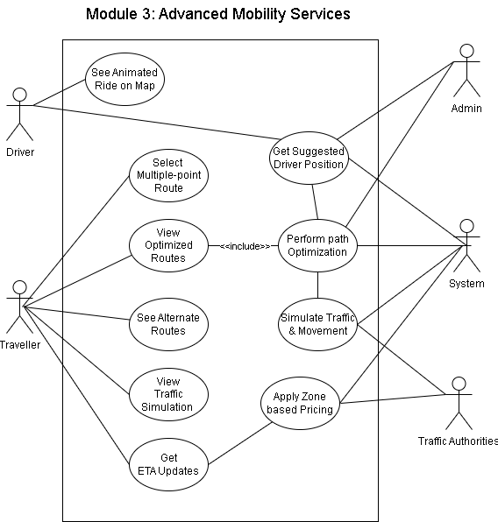

**Fig 2.12: Advanced Mobility Services**

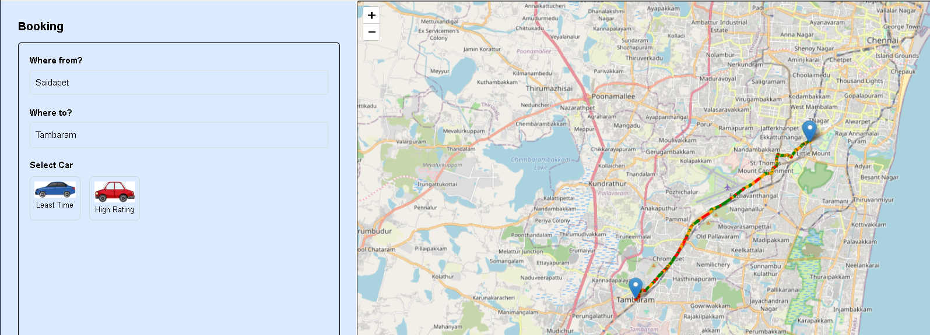

**Fig 2.13:** Shows **Optimize Route and Traffic Simulation**

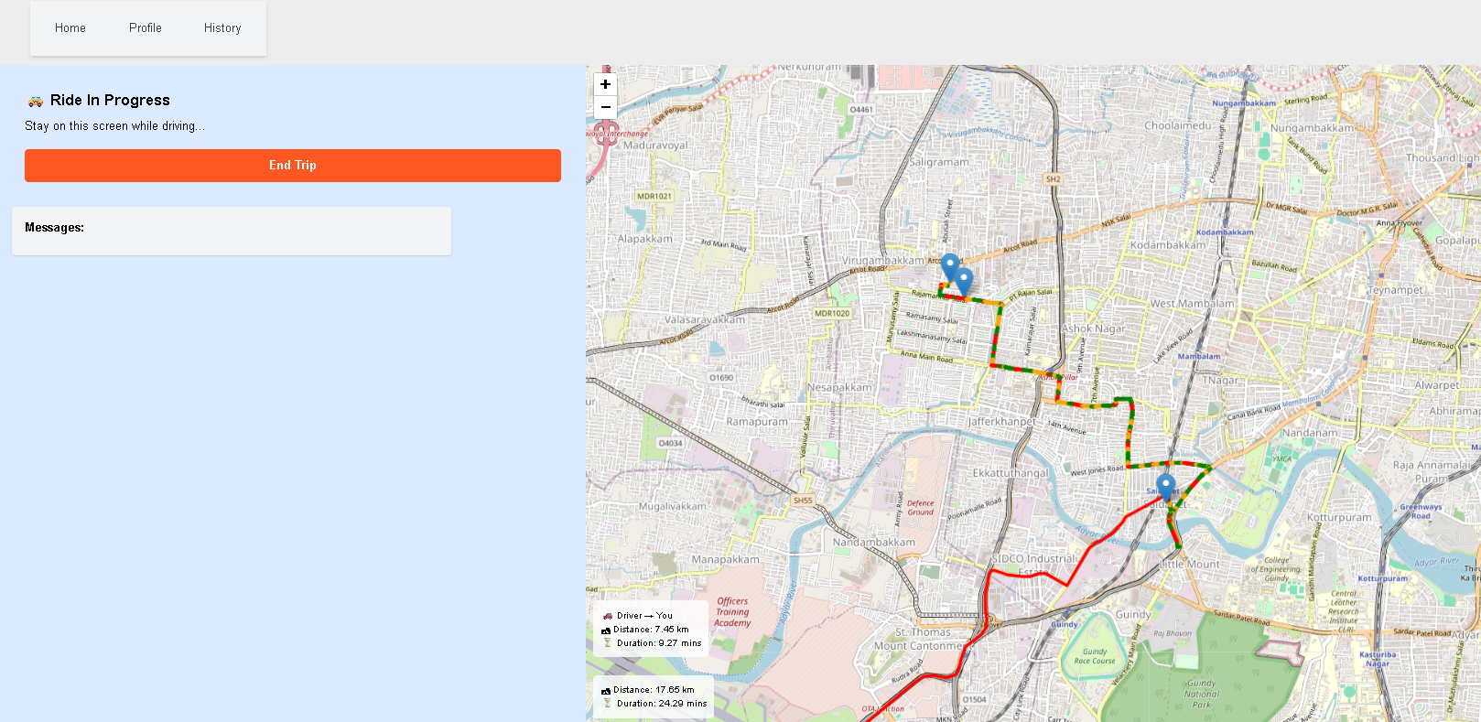

**Fig 2.14:** Shows Rider Progress